**Master Functional Document**

|  |  |
| --- | --- |
| **Application** | NGERP - Centra |
| **Service Bundle** | Master Management |
| **Service Request** | Scheduler Email Configuration |

**Description :**

In scheduler MasterUser’s can be added to the scheduler recipient to receive status of the Scheduler job via email. The user’s will be notified via email if a scheduler job started or ended.

**Workflow Process :**

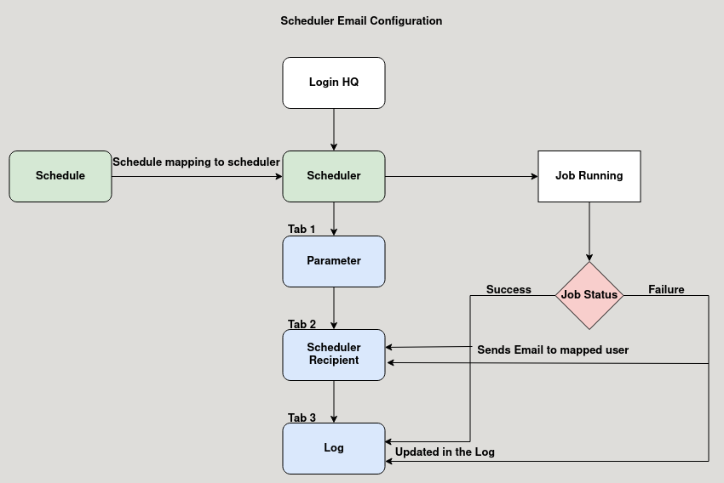

**Business Rules :**

* Click test run to run the Database job, after the job completed it shows success message.
* A schedule is mapped to the scheduler master to run the job at specific time and day.
* Either the job is success or failure, user can check the details in the log tab.
* The scheduler recipient tab is used to map user to send email alert about the job status.
* Job status of the scheduler is sent to the user inspite of success or failure.